Honor Band Snare Drum Rudiment Requirements:

Long Roll Drag
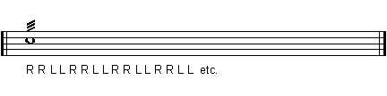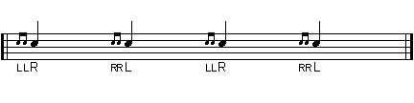
5 Stroke Roll – use first example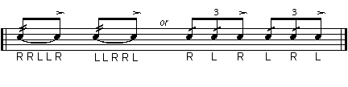
9 Stroke Roll
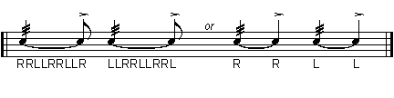
Flam
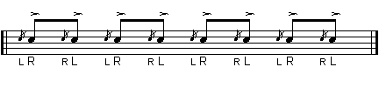
Single Paradiddle
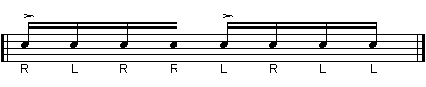

Single Ratamacue
