EATON MIDDLE SCHOOL BAND GEAR

SHIRT DESIGN:

Front left Back of shirt 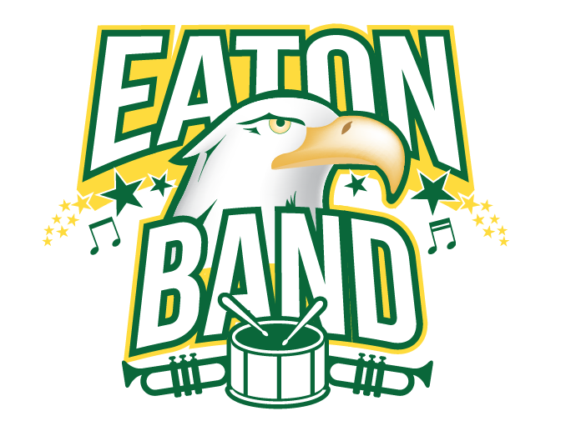
EATON BAND

*T-shirts will be black and the artwork will be green, yellow and white.

* Single color hoodies available in black, ash (light gray), and kiwi with the same artwork.
Available sizes are S, M, L, XL, 2XL, and 3XL. These are adult sizes only.

*Color Block (Grey and Black) Hoodie
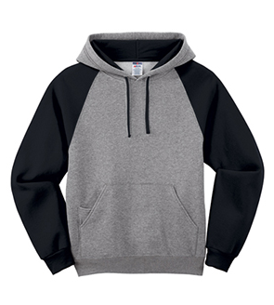
*Bags are Black with front of shirt design in white

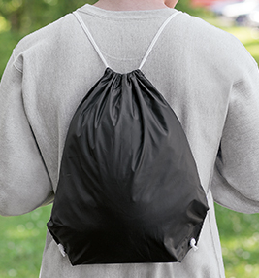

FORMS AND MONEY DUE TUESDAY, OCTOBER 15th
EATON MIDDLE SCHOOL BAND GEAR ORDER FORM

Student Name:___________________________________________ Grade:________

Parent Name: ____________________________________Phone #:_______________

- T-Shirt ($15.00): White only
S M L XL 2XL 3XL

Total # of t-shirts:__________________________ (x $15) = $_________________

- Sweatshirt ($25.00) Check one size and color per row. Name of buyer at end.
S M L XL 2XL 3XL BLK Ash Kiwi NAME

Total # of sweatshirts:__________________________ (x $25) = $_________________

- Color Block Sweatshirt ($30): Black and Gray combined only
S M L XL 2XL 3XL

Total # of sweatshirts:__________________________ (x $30) = $_________________

- Drawstring Bag: Black with white front of shirt logo
Total # of bags:__________________________ (x $10) = $_________________

Total Amount Due: $_____________

Cash or check made out to Eaton Middle School. Orders and money are due by October 15th. Thank you for your support of our fine Eagle Musicians!!!

